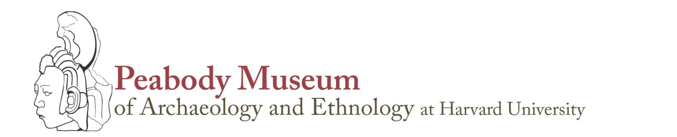
Template for instructors teaching with collections

- After this experience with collections, students will be able to:
a.
b.
c.

- Some pre- or post-visit readings/videos that would support Indigenous perspectives or knowledges in relation to the collections could be:

- What will I say to the class in advance to emphasize that Indigenous people are present, vibrant, and engaged in interpreting their own stories?

- My key question to pose to students before viewing collections is:

- Some likely questions I may need to prompt students are:
a.
b.
c.

- How much time will I allocate for:
- student small group discussion?
- individual or group exercises?
- whole group discussion?
- instruction or summary from me?
(Note: 75%+ of class time should be spent on student response, discussion, or activity, rather than instructor comments or lecture.)

- Do I anticipate emotional student responses?
Will students need class time for private reflection?
How much time?

- Is there a question or assignment I can raise that would let me know if students are “getting it” before they leave the room?

- Are there questions I have now (e.g. how the collections came to the museum; contemporary collections care; advice on preferred terminology) that I should ask Academic Partnerships before class?
11 Divinity Ave. Cambridge Massachusetts 02138 617-496-1027 www.peabody.harvard.edu

